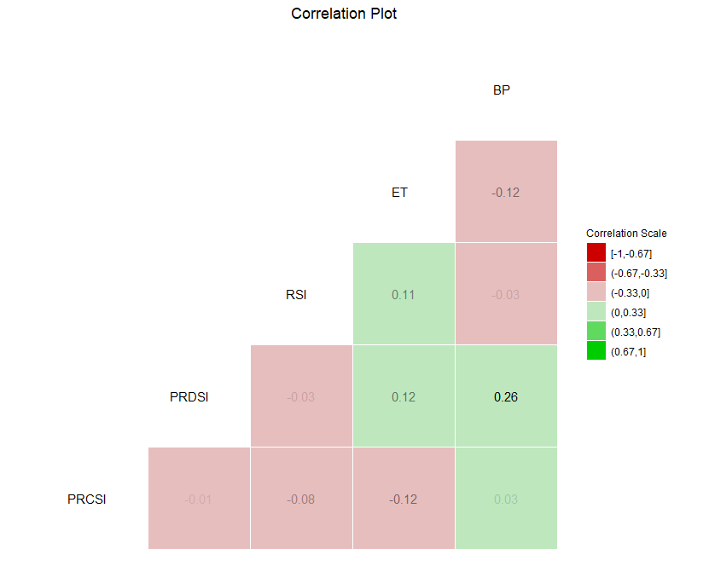**Correlation**

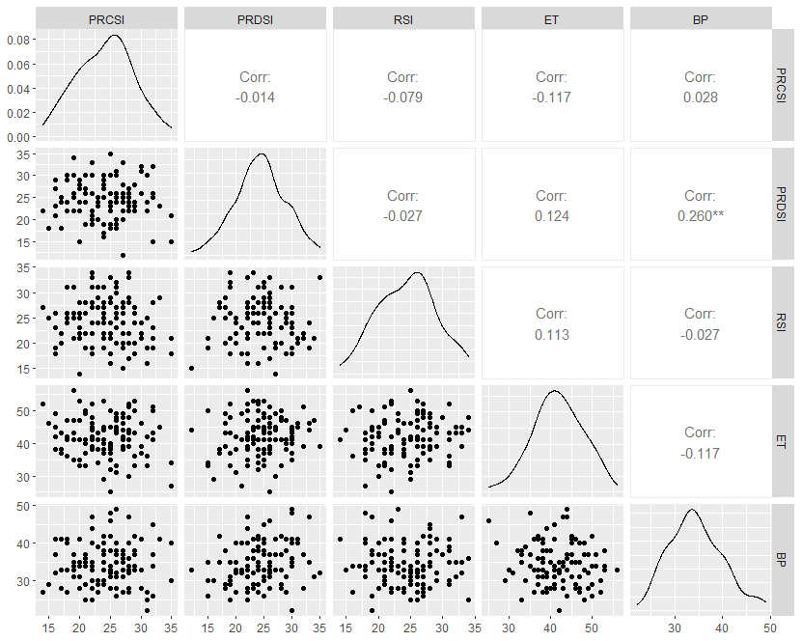

**Regression Assumption**

**Linearity of the data**. The relationship between the predictor and the outcome is linear.  the residual plot shows no fitted pattern. That is, the red line is approximately horizontal at zero.

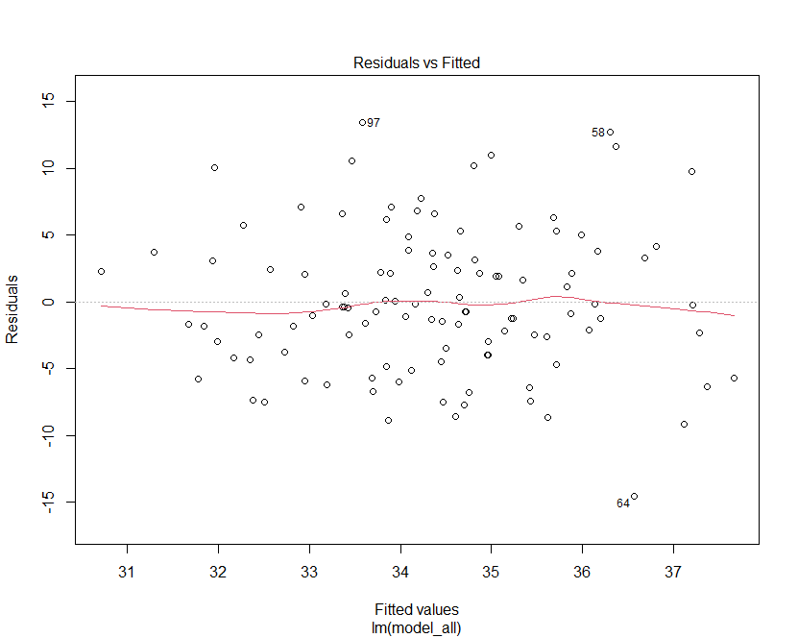

**Normality of residuals**. The residual errors are normally distributed.

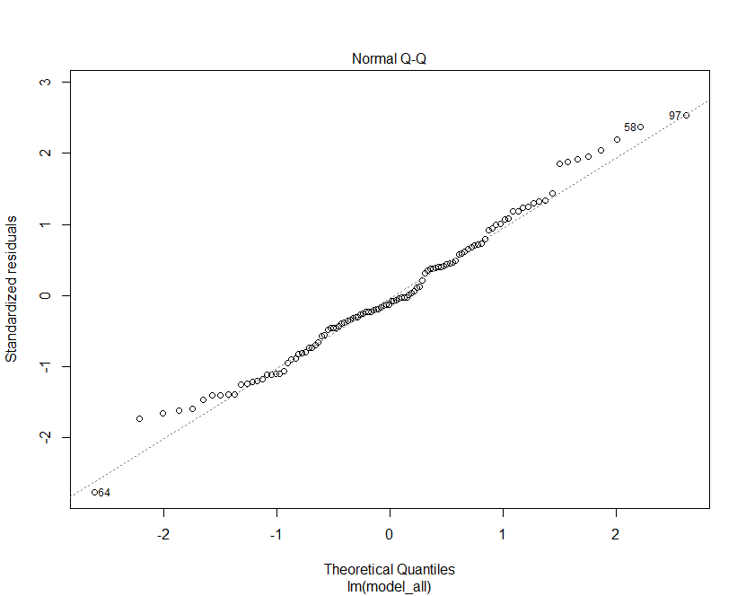

**Homogeneity of residuals variance**. The residuals are a constant variance (**homoscedasticity**)

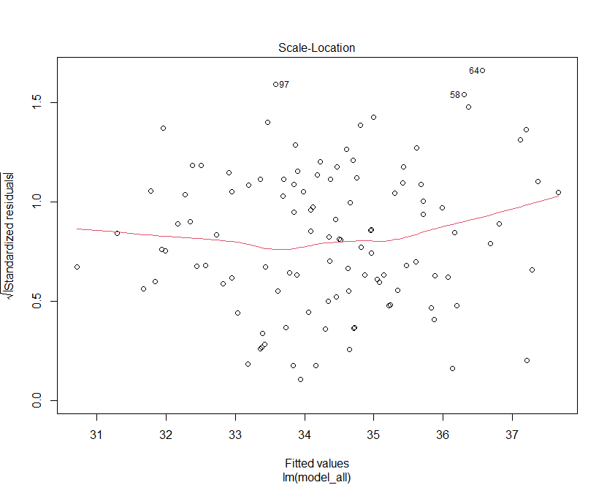

**Outliers and high levarage points**

